Apache ActiveMQ

<https://activemq.apache.org/index.html>

Installasi :

1. Buka link berikut

[https://activemq.apache.org/getting-started#OnUnix](https://activemq.apache.org/getting-started" \l "OnUnix):

1. Pre installasi

sebelum install ActiveMQ, langkah awal yang harus diperhatikan adalah menginstall java dan maven .

Langkah install java  
$ sudo apt update  
$ java -version  
$ sudo apt install default-jre

$ java -version

Output

openjdk version "10.0.1" 2018-04-17

OpenJDK Runtime Environment (build 10.0.1+10-Ubuntu-3ubuntu1)

OpenJDK 64-Bit Server VM (build 10.0.1+10-Ubuntu-3ubuntu1, mixed mode)

$ sudo apt install default-jdk

$ javac -version

Output

javac 10.0.1

$ sudo nano /etc/environment

JAVA_HOME="/usr/lib/jvm/java-11-openjdk-amd64/bin/"

$ source /etc/environment

$ echo $JAVA_HOME

Output

/usr/lib/jvm/java-11-openjdk-amd64/bin/

Langkah install maven dari package  
$ sudo apt update

$ sudo apt install maven

$ mvn -version  
$ sudo nano /etc/profile.d/maven.sh  
export JAVA_HOME=/usr/lib/jvm/java-11-openjdk-amd64/bin

export M2_HOME=/usr/share/maven

export MAVEN_HOME=/usr/share/maven

export PATH=${M2_HOME}/bin:${PATH}

$ sudo chmod +x /etc/profile.d/maven.sh

$ source /etc/profile.d/maven.sh

$ mvn -version

Output

Apache Maven 3.5.2

Maven home: /usr/share/maven

Java version: 10.0.2, vendor: Oracle Corporation

Java home: /usr/lib/jvm/java-11-openjdk-amd64

Default locale: en_US, platform encoding: ISO-8859-1

OS name: "linux", version: "4.15.0-36-generic", arch: "amd64", family: "unix"

Langkah install maven dari source  
download maven melalui link berikut

<https://maven.apache.org/download.cgi?Preferred=ftp://mirror.reverse.net/pub/apache/>

$ sudo tar xf /tmp/apache-maven-*.tar.gz -C /opt

$ sudo ln -s /opt/apache-maven-3.6.0 /opt/maven

$ sudo nano /etc/profile.d/maven.sh  
export JAVA_HOME=/usr/lib/jvm/java-11-openjdk-amd64/bin

export M2_HOME=/opt/maven

export MAVEN_HOME=/opt/maven

export PATH=${M2_HOME}/bin:${PATH}

$ sudo chmod +x /etc/profile.d/maven.sh

$ source /etc/profile.d/maven.sh

$ mvn -version

1. Install ActiveMq

download ActiveMq melalui link berikut

<https://activemq.apache.org/components/classic/download/>

sedangkan rilis versi sebelumnya dapat dilihat pada link berikut

<https://repository.apache.org/content/repositories/snapshots/org/apache/activemq/apache-activemq/>

# tar zxvf activemq-x.x.x-src.tar.gz

# cd [activemq_install_dir]/bin

# chmod 755 activemq

Gunakan perintah ini untuk menjalankan *daemon* proses activemq

# ./activemq start

Gunakan perintah ini untuk menjalankan *foreground* proses activemq

# ./activemq console

Gunakan perintah ini untuk memberhentikan activemq

# ./activemq stop

1. Pengujian

Buka browser, kemudian ketikkan alamat berikut  
[http://localhost:8161/admin/](http://127.0.0.1:8161/admin/)

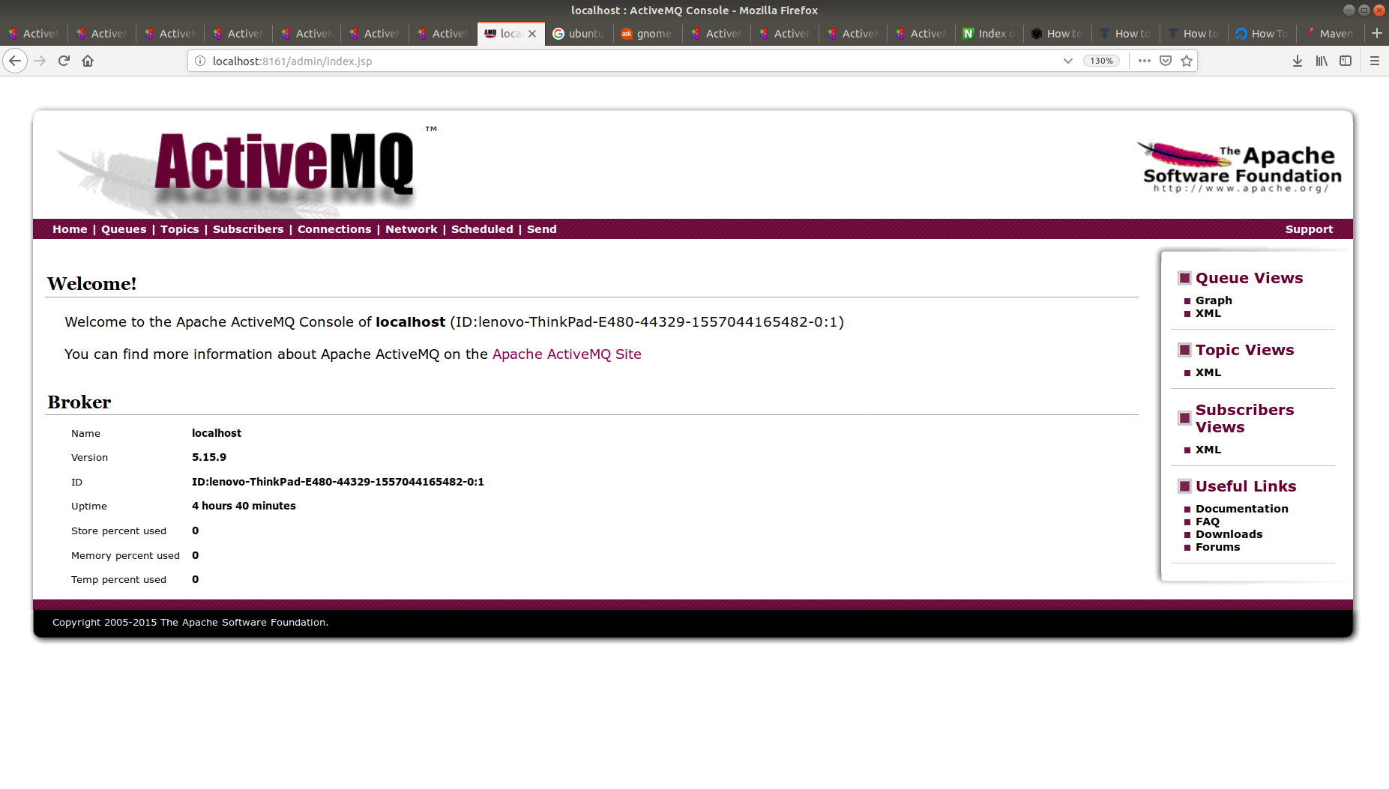Login: admin  
Password: admin

1. Pengecekan port

# netstat -nl|grep 61616

tcp6 0 0 :::61616 :::* LISTEN